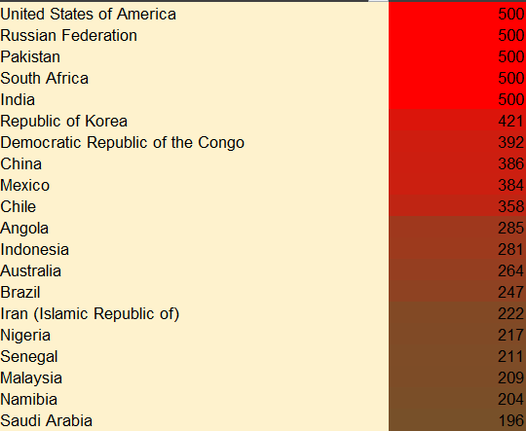

**Reference: Kaggle.com**

6

**Recommendations**

**Incorporate Temporal Data:** Include time-series data to facilitate the analysis of seasonal and diurnal pollution trends. **Source Identification:** Integrate emission source data to enable targeted and efficient interventions.

5

**Conclusion**

This report highlights the importance of multi-parameter air quality monitoring to identify pollution hotspots and guide mitigation efforts. Addressing dataset limitations can improve its effectiveness.



Among pollutants, **PM2.5 AQI** shows the strongest correlation with overall AQI, highlighting its significant role in determining air quality. Sardulgarh, Nohar, Boksburg, Durango, Pokaran, Hasanpur, Jalalabad are the city which have 500 PM2.5 AQI value.

Methodology: 1 Data Cleaning: Ensured accuracy by handling duplicates and inconsistencies. 2 Descriptive Statistics: Summarized pollutant AQI metrics. 3 Geospatial Analysis: Mapped AQI values to visualize regional differences. 4 Categorical Analysis: Analyzed AQI categories for pollutants. 5 Trend Identification: Explored pollutant correlations and AQI trends. 6 Question Analysis: Answered dataset-based queries (A1–A8).

United States of America, Russian Federation, Pakistan, South Africa ,India are the highest AQI value 500,which is categorized as Hazardous

4

**Result**

**Data Set Analysis**

**STEP 1**

**STEP 2**

**STEP 3**

**STEP 4**

**STEP 5**

**STEP 6**

Data Set Analysis:

The "AQI and Lat Long of Countries" dataset offers a comprehensive framework for analyzing air quality across countries and cities. It includes detailed columns such as country, city, aggregated AQI values and categories, pollutant-specific AQI data (CO, Ozone, NO₂, PM2.5), and geographical coordinates (latitude and longitude). The data reflects significant variation in AQI values, enabling robust geospatial and categorical analysis to understand regional pollution patterns and sources.

3

**Methodology**

Pollution refers to the presence of harmful substances in the environment, including air, water, and land.

The Air Quality Index (AQI) is a tool used to report daily air quality. It tells you how clean or polluted the air is and what associated health effects might be a concern.

2

1

**Introduction**

**Multi-Parameter Air Quality Monitoring System**